m/

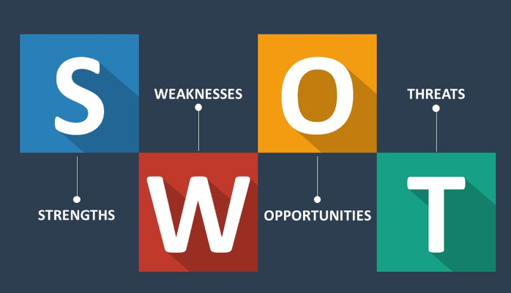

Use the following questions to support you in conducting a self SWOT analysis:

**Strengths (don’t be modest):**

* How do your education, skills, talents, certifications, and connections / networks set you apart from your peers?
* What would your boss or coworkers say are your strengths?
* Ability to get work done with a friendly attitude.
* What resources do you have at your disposal?
* I have laptops, books, Wi-Fi and most importantly my facilitators.
* What contributed the most to your past victories?
* Hard work and pushing beyond the limit.
* What values or ethics do you have that your peers often lack?
* Self-drive.
* What achievements are you most proud of?
* My high school studies and a place at Akirachix

**Weaknesses (be honest):**

* Where are your education, training, or skills lacking? What’s missing and needs improvement?
* Social skill
* Fluency in communicating (mostly in public)

* What would your boss or coworkers say are your weaknesses or areas of improvement?
* Feeling that am right event when am wrong.
* What are your negative work habits and personality traits?
* Going to work late.
* What do you avoid because you lack confidence?
* Public address.

**Opportunities:**

* Which opportunities are you not exploiting at the moment?

*

* What trends are affecting your industry – the industry you belong to or wish to be in?
* In what areas is your industry growing?
* More women are joining Tech
* How could new technology help you advance?
* Learn to work online which will bring in more income.
* How could your connections and networks help you?
* Acquire job

**Threats:**

* What obstacles do you currently face in your career and life?
* Who is your competition?
* Poverty.
* Will new technology or certifications demands slow your progress in achieving your goals?
* No.
* How is your job or industry changing in ways that could affect your advancement?

S.W.O.T

|  |  |
| --- | --- |
| Strengths   * Flexibility and Adaptability * Tolerance: Stress tolerance * Critical thinking: Decision making skills * Positive Attitude: Creating a positive work environment * Financial management * Intelligent * Leadership * Responsible * Listening * Goal oriented: results achiever, Meeting deadlines * Self-Motivated * Personal Management * Loyalty | Weaknesses   * Not taking criticism well * Impatient * Lazy * Easily bored * Procrastinate * Persistent * Allows emotions to show * Selfish * Focusing on small details * Takes blame for others * Being straight forward * Follow-ups * Aggressive * Likes to take risks * Critical of others * Works to much |
| Opportunities | Threats |